Cutting Down on Processed Meat and Dairy Will Save the Environment 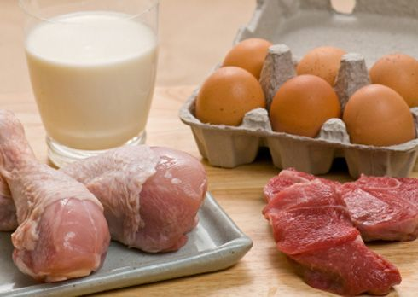
Kenyah De La Cruz, DuVal High School 4:49 p.m. EDT June 2, 2016 (Photo: Google)

If we do not change the way we live now, our children and our children's children will pay for it even more than we have already started to. Climate change is real and is no longer ignorable as it’s effects have already begun to affect the planet and human health.

But, it’s not too late to fix our wrongs and save the environment one step at a time.

Starting with cutting down the amount of processed meat and dairy you eat a day.

According to Food’s Carbon Footprint by GreenEatz.com food produces about eight tons of greenhouse gas emissions per household. With that said, that means food production and waste is accountable for 17% of the greenhouse gases killing our environment.

Of that 17% about 28% of the greenhouse gas emission comes from meat and dairy production. While the next leading food for greenhouse gases behind meat and dairy is rice.

The less meat and dairy a person consumes the lower their carbon footprint. Now, I’m not saying to cut meat and dairy out of your diet completely.
But a good way to start is by changing your diet by only including meat in two of you meals a day and dairy products down to one meal per day.

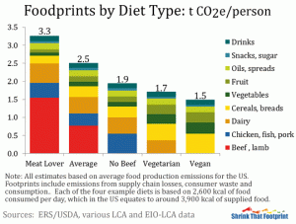
Michael Pollan, Food Writer, sums it up best by saying “Eat Food. Not Too much. Mostly plants.”

In the graph above you can see that people that consume more fruits and vegetables have a lower carbon footprint, this is because according Environmental Working Group’s Meats Eater’s Guide and EPA’s Guide to Passenger Vehicle Emissions vegetables and fruits have some of the lowest food emissions of greenhouse gases.

The only food with less greenhouse gas emissions being lentils.

Some may argue that is it not health for a person to live healthily without meat or dairy or with low levels of meat and dairy in their diets but that is not true. People who consume less meat and dairy tend to live healthier longer lives.

According to a study by LifeExtension.com vegetarians under the age of 65 are 45% less likesly to suffer a heartattck than a meat eater. While a study by Seventh Day Adventists found that that little to no meat increases the male life by 7.28 years and the female life by 4.42 years.

The best way for you, and the world to help fight climate change is by cutting down on the amount of meat and dairy you eat.

When I interviewed, Tumblr Food and Environment expert, Davona Sanders she stated “yes (she believe climate change can be reversed) if we decrease carbon dioxide that is being released into the air.”

Decreasing your intake of meat and dairy can do just that, decrease the amount of carbon dioxide released.

When I shared the idea of decreasing meat and dairy in a person’s daily diet in order to decrease greenhouse gas emissions all Davona had to say was “Yes that would work. But would people do it? No, The simple fact is people love meat. Come on now, people won’t just stop eating what they like.”

When I asked her if people would do it if they knew that it meant potentially saving our planet and increase their health Davona answered “People are cruel, okay? Even if it may help them and the environment, there are still two types of people in the world: those who care about the future of the world and those who just care about what's happening to them now.”

So which kind of person are you? The one who cares about the future of our planet and climate change or the person too interested in their own current well being without thinking about the effects their actions have on the world and environment.

Climate change is not only one person’s problem. It is the world’s problem and is slowly affecting us all as temperatures increase and sickness spreads.

Now it may seem hard, but if we all work together to decrease our carbon footprints we can save the environment and insure a future for the next generations all you have to do is simply eat less meat and dairy.

